In this class assignment you will demonstrate a detailed knowledge of basic Drupal CMS skills by creating and managing Drupal 8 CMS sites on various.   
The goal of this assignment is to demonstrate that you have learned how to use best practices to create and extend Drupal 8 CMS sites with Core, Contributed, and Custom Modules.   
 **Assignment questions are not as detailed as activity questions. The assignment is where you demonstrate understanding of the material.  
  
Read All Project Documents before Starting the Work**Please read this document completely before starting the project work.   
Please also read the template so that you understand what information, content, and screens you are required to capture and insert into the template file.

**Documents for This Assignment:**   
This is the assignment instructions document.   
It contains the information on the necessary tasks to be completed for the assignment.  
The other documents associated with this assignment are the assignment template, the website content, and the rubric.   
  
**Template File:**   
Please download, rename, complete and then submit the assignment template document to receive a grade for this assignment. Please provide partial screen captures where requested.  
The rubric provides detailed information on how the assignment is graded.  
**PLEASE DO NOT DELETE PARTS OR ALTER SECTION NUMBER FORMATTING OF THIS TEMPLATE**

**Assignment Asset Folders and Website Content:**No assets file for this assignment.

Part A - Student Information

1. Download and save a copy of the Assignment 08 Template document
2. Rename the template document **[Your-Name or Initials]-**Assignmen-08-Template.docx
3. Go to the template and enter student information for Part A.

Part B - Create Drupal 8 CMS Website on Shared Web Host or PaaS

1. If you are using a **shared web host** create an “In Directory” Drupal 8 CMS website with the following attributes:

**Version: Most Recent Drupal 8 Version (8.8.0 as of Dec 17th 2019)  
INSTALLATION URL:**

**Protocol:** http:// **Domain:** Select your default domain **In Directory:** “mod08assign08”

**CRON Job Settings: Keep Default Settings**

**Site Name:** “Yet Another Drupal 8 Assignment Site”

**Admin Account:**

**Admin Username: Keep default or add a strong username**

**Admin Password: Keep default or add a strong password**

**Admin email: admin@[your-domain -name]**

**Advanced Options:**

Database Name: Use your web hosts default database name

Database Prefix: Use your Web hosts default database prefix

Backup Location: Keep default value

-OR-

**2. If you are creating a Pantheon Drupal 8 CMS site:**

Create a sandbox site Pantheon Drupal 8 site with the following attributes:  
  
**Name Your Pantheon Site:** “[Your Initials] – Assignment 08–PA”  
**Your Pantheon Development Site URL:** Keep default value  
**Choose an Organization:** None  
**Choose a Region for the Site:** United States

Deploy a Drupal 8 Site.

Configure Site:

**Site name:** My Assignment 08

**Site email address:** Use the email you used to establish the PaaS account

**Username:** enter a strong username (record it)

**Password:** enter a strong password (record it)

Regional Settings:

**Default Country:** United States  
 **Default time Zone:** Select appropriate city (Chicago)

UPDATE NOTIFICATIONS  
 **Check for Updates automatically:** selected (Checked)

**Receive email notifications:** Selected (checked)

1. Go to the template and record website creation settings in Part B.

Part C - Harden Shared Web Host Drupal 8 Site

1. Harden your Drupal 8 site by setting “Administrators only” as the role that can register new accounts
2. Open the Assignment 07 template and take the screen captures for Part C.
   * Admin toolbar > Configuration > Accounts settings > REGISTRATION AND CANCELATION section
   * Admin toolbar > People page

Part D – Answer Template Questions

1. Open the Assignment 07 template answer the questions for Part D

Part E - Extend the Shared (or PaaS) Drupal 8 Site with Core ModulesReplicate work performed in this week’s tutorial.

1. Implement a Core Contact Us page using the Drupal 8 Core Contact Module
2. Add a “Contact us” main navigation menu link to the site
3. Reorder the main navigation menu so that the “Contact us” menu item is to the last item on the right and is positioned to the right of Home
4. Test your site as an anonymous user
5. Open the Assignment 07 template answer the questions for Part E

Part F - Extend the Shared (or PaaS) Drupal 8 Site with Contrib. ModulesReplicate work performed in this week’s tutorial.

1. Implement a FAQ page using the Frequently Asked Question Module
   * <https://www.drupal.org/project/faq>
2. Permission the FAQ page appropriately so that anonymous site visitors can view it
3. Add three (3) FAQ nodes (Questions and Answers) – design your own questions and answers
   * Please write actual questions and answers.
   * Do not use Question 1, and Answer 1.
     1. If you do, you will get points taken off.
4. Configure the FAQ module Categories layout and MISCELLANEOUS LAYOUT SETTINGS to enable the "accordion" style effect where when a category is clicked, the questions appears beneath, and is then hidden when another category is opened.
5. Add an FAQ link to the main navigation menu
6. Re-order the FAQ menu link so it is positioned to the left of the “Contact us” menu item and to the right of the Home link.
7. Test your site as an anonymous user
8. Open the Assignment 07 template answer the questions for Part F

Part G - Extend the Shared (or PaaS) Drupal 8 Site

Background:  
You are a Drupal 8 developer working a project. Your client wants you to research the new Drupal 8 paragraphs module and if there is a valid version for Drupal 8, install it, and all additional modules it requires. So you can test it out on your assignment 08 Drupal 8 test site.   
  
Drupal 8 Project Page URL:  
<https://www.drupal.org/project/paragraphs>

Read about Paragraphs on Drupal.org  
<https://www.drupal.org/docs/8/modules/paragraphs>

Watch one or more training videos on Drupal 8 Paragraphs:  
Drupal 8 Site Building, 8.1: Introduction to Paragraphs  
<https://www.youtube.com/watch?v=HFL_Khg38ZU>

Drupal 8 Paragraphs Demonstration  
<https://www.youtube.com/watch?v=6ti2l8HB5Qc>

Your Tasks:

1. Read and watch training videos on the Paragraphs module
2. Read the Paragraph project page (see link above)
3. Determine if there is a valid Drupal 8 version of the Paragraph
4. If there is a valid Drupal 8 version, Install the Paragraphs module on your Drupal 8 site
5. Examine the Extends Paragraph section to determine additional required prerequisite modules
6. Draw up a list of the required prerequisite modules for all the Paragraph modules listed EXCEPT for the Paragraphs Demo module
7. Search for and find the project page URLS for the necessary perquisite modules
8. Install the required Paragraph prerequisite modules on your Drupal 8 site
9. On the Drupal 8 site backend, Extends page, Paragraphs section, enable the Paragraphs, Paragraphs Library, and Paragraph Type Permissions modules.   
   Do not enable the Paragraphs Demo module.   
   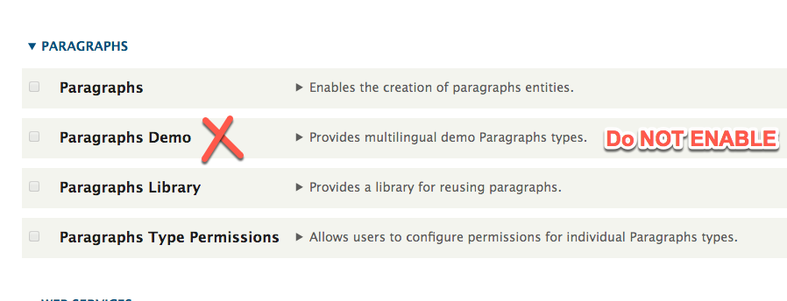
10. Before you can create Paragraph node content, the Paragraph module must be configured.   
    We will stop here and not configure the Paragraph module.   
    You can continue on your own, configure it and create content nodes with paragraphs of IPSUM content if you like, but it is not part of this assignment.
11. Open the Assignment 07 template answer the questions for Part G

Part H – Use Existing Codeanywhere Drupal 8 CMS Website

Go to the template and record website login credentials for your existing Codeanywhere site on the Assignment Template at Part H.

For Part I, refer to presentation “Build Drupal 8 CMS Modules on Codeanywhere” for details.

Part I - Extend the Drupal 8 Site **with a Custom Plugin**

1. Use Codeanywhere for this part
2. Create a Drupal 8 custom module with the following attributes:
   * Machine name: my_first_d8cm
   * Description: This is My First Drupal 8 Custom Module
   * info.yml file name: my_first_d8cm.info.yml
   * routing.yml file name: my_first_d8cm.routing.yml
   * Controller file name: MyFirstD8CM.php
3. Create your Drupal 8 custom module and then access the using the routing path to display “This is My First Drupal 8 Custom Module” on your Drupal 8 site
4. This is the same type of work we did in the Tutorial, and I expect that you will use the tutorial files as your baseline template, copying and renaming files to conform to your custom modules machine name.
5. Doing this on Codeanywhere is complicated, so move slowly and carefully and use the presentation as your guide.
6. Once you complete implementing the custom module on your site, go to the template and record website login credentials for your existing Codeanywhere site on the Assignment Template at Part I.
   * The grader must be able to start the Codeanywhere connection-container in order to test the module for partial credit.
   * Missing or incomplete screen captures combined with incomplete site credentials will not receive full credit.

**Part J – Assignment Wrap up:**

1. Go to the template and answer the questions in Part J, the assignment wrap up.
2. Answers to questions 1-3 are required to receive points on this section
3. After answering these questions, submit your template to D2L.  
     
   Submit this completed template to the D2L assignment 02 dropbox.If you prefer not to navigate by hand to the D2L dropbox, take advantage of the dropbox link in the D2L current Assignment section. Or PaaS